Installing the CH340 driver

Before continuing operations make sure Keil C51 has been installed

1. Open the CH340_CH341 folder in the USB to UART Driver folder in the stc-isp-15xx-v6.86B folder in the file, with ch341ser.exe.

Double-click to open the file.

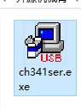 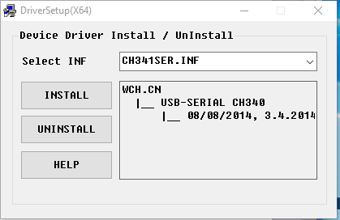

1. Click the Install button and the Install and Uninstall buttons are grayed out. A moment later, the prompt installation is successful.

